**Week 1: (1.5 Hours)**

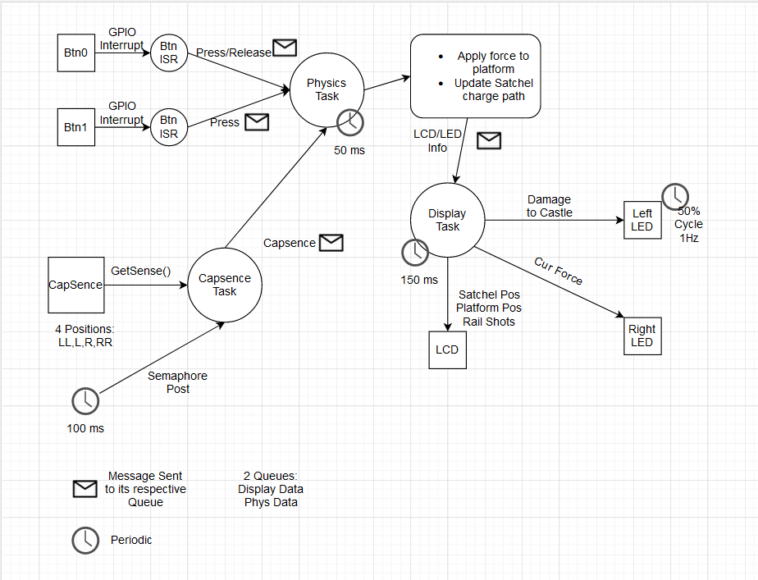

**Test Plan and Results:**

* 2 Cutting points for testing:
  + The 2 fundamental cutting points that jump out to me are my two message queues. In my system I plan on sending all of my physics information to my physics task via one queue, and my display information to my display task via another queue. If I put cut offs at these message queues I can easily split up and unit test my project.
* What would I be unit testing?:
  + With just two cut off points I can unit test a lot. I am able to test the functionalities of my buttons and capsense detection by determining if the correct values are passed into the queue. This is simple because there is no data being passed into any task before this point so I do not have to generate any false data sets to test on. However, I would need to generate a set of false data points to generate a fake queue for my Physics task to be unit tested on. This would allow me to make sure I am generating the correct Platform and Satchel positions. Lastly, I can generate fake data sets coming out of my physics task to test if updating the values being passed to the LED, and LCD are correct.

**Statement of where the project stands:**

* Deliverables
  + Currently I have set up a task diagram where I have set up the initial behaviors of all of my tasks, timers and ITC systems. In addition I wrote out what my task should be doing in a notebook to track the logic of each task. I have also made small decisions about some of the choices we have with the project, for example, I have decided that I will be using 4 positions on the Capsense as this is what I have implemented in the past and it will work well for this application. Lastly, I have chosen 2 of my cuttings points for unit testing and have determined 3 different unit tests.
* Summary effort and estimate numbers:
  + I have not established a scope with an instructor, however I would estimate that I have done **3.75%** of my currently estimated work (**1.5** hours out of **40**), I thought that this would take **2** hours out of the total **40**. I have work **75%** of what I thought.
  + I have completed my task diagram and have a rough outline for the functionality of every task/function.

**List of in-scope work items:**

* Task Diagram
  + This diagram was pretty easy to setup but I am glad I created it. It gave me a better visual understanding of what I have stored in my head for how I want to plan this out. It will save time in the future when I am confused. It did make me question a few things such as:
    - 1.)How am I going to periodically access the physics task and the display task, should I use a timer delay?
    - 2.)What timer will be in charge of the 1Hz cycle for the Left LED
    - 3.)What kind of struct will I be using to pass messages in my queues?

**Updating Risk Register:**

Added Two Risks today:

